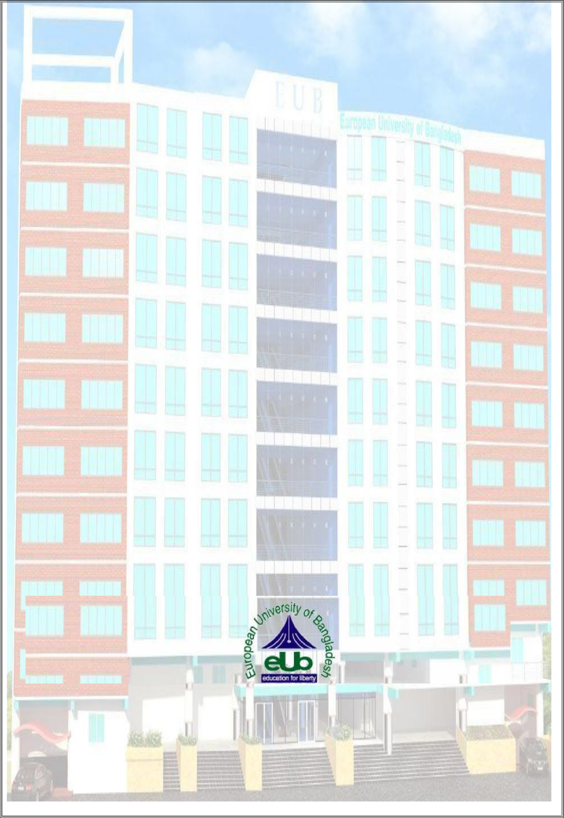**Project Report**

**On**

**“EUB-APGT (AUTOMATED PAYROLL AND GPS TRACKING)”**

**Submitted By**

**Student Name: Sourav Kundu**ID: 180222042

**Student Name: Farid Hossain**ID: 180222047

**Student Name: Md Abid Hasan**ID: 180222048

**Supervised by**

**Shraboni Afroz**

Sr. Lecturer

Department of Computer Science and Engineering

**A project submitted in partial fulfillment of the requirements for the degree of Bachelor of Science in Computer Science and Engineering**

**Department of Computer Science and Engineering**

**European University of Bangladesh**

2/4, Gabtoli, Mirpur, Dhaka-1216

January 2022

**CANDIDATES DECLARATION**

This is to certify that the work presented in this project, titled, “**EUB-APGT (AUTOMATED PAYROLL AND GPS TRACKING)**”, has been done by us under the supervision of Shraboni Afroz.

We also declare that neither this project nor any part of this project has been submitted anywhere else for the award of any degree, diploma, or other qualifications.

Signature

--------------------

Sourav Kundu  
ID: 180222042

Signature

----------------------  
Farid Hossain  
ID: 180222047

Signature

--------------------  
Md Abid Hasan  
ID: 180222048

**CERTIFICATE OF APPROVAL**

This project titled, **“EUB-APGT (AUTOMATED PAYROLL AND GPS TRACKING)”**, submitted by the group as mentioned in the candidates’ declaration page has been accepted as satisfactory in partial fulfillment of the requirements for the degree B.Sc. in Computer Science and Engineering on 25th October 2021.

**Signature of Supervisor**

**---------------------------------------**

**Shraboni Afroz**

**Sr. Lecturer**

**Department of Computer Science and Engineering**

**The European University of Bangladesh, Dhaka, Bangladesh.**

**Signature of Chairman**

**---------------------------------------------**

**Md. Obaidur Rahman**

**Associate Professor and Chairman**

**Department of Computer Science and Engineering**

**European University of Bangladesh, Dhaka,**

**Bangladesh**

**ACKNOWLEDGEMENT**

We would like to express our gratitude and appreciation to all those who allowed us to complete this report. A special thanks to our final year project coordinator, **Shraboni Afroz, Sr. Lecturer, Department of CSE, European university of Bangladesh**, whose help, stimulating suggestions and encouragement, helped us to coordinate our project especially in writing this report. We would also like to acknowledge with much appreciation the crucial role of the staff of the computer science and engineering lab, who permitted to use all required machinery and necessary material to complete the project. Last but not least many thanks go to the head of the project, **Md. Obaidur Rahman, Associate Professor, and Chairman, Department of CSE, European University of Bangladesh**, who have given his full effortguiding the team in achieving the goal as well as his encouragement to maintain our progress on track. We would like to appreciate the guidance given to another supervisor as well as the plan especially in our project presentation that has improved our presentation skills by their comment and tip.

**Table of Contents**

|  |  |  |
| --- | --- | --- |
| SL No. | Chapter Name | Page No. |
| 01 | Project Details Front Page | 1 |
| 02 | Candidates Declaration | 2 |
| 03 | Certificate of Approval | 3 |
| 04 | Acknowledgment | 4 |
| 05 | Table of Contents | 5 |
| 06 | List of Figures | 6 |
| 07 | Abstract | 7 |
| **Chapter 1: Introduction** | | |
| 1.1 | Introduction | 8 |
| 1.2 | Motivation | 9 |
| 1.3 | Objective | 9 |
| 1.4 | Expected Outcome | 9 |
| **Chapter 2: Background** | | |
| 2.1 | Introduction | 10 |
| 2.2 | Related Works | 10 |
| 2.3 | Comparative Studies | 11 |
| 2.4 | Challenges | 12 |
| **Chapter 3: Requirement Specification** | | |
| 3.1 | Requirement Collection Analysis | 13 |
| 3.2 | Use Case Modeling and Description | 14 |
| 3.3 | Logical Data Model | 15 |
| 3.4 | Design Requirements | 16 |
| **Chapter 4: Design Specification** | | |
| 4.1 | Front-End Design | 17 |
| 4.2 | Interaction Design and UX | 18 |
| 4.3 | Back-End Design | 19 |
| 4.4 | Implementation Requirements | 19 |
| **Chapter 5: Implementation and Testing** | | |
| 5.1 | Implementation of Database | 20 |
| 5.2 | Implementation of Front-end Design | 21-32 |
|  |  |  |
| SL No. | Chapter Name | Page No. |
| **Chapter 6: Impact on Society, Environment and Sustainability** | | |
| 6.1 | Impact on Society | 33 |
| 6.2 | Limitation | 33 |
| 6.3 | Obstacles & Achievements | 33 |
| **Chapter 7: Conclusion and Future Scope** | | |
| 7.1 | 1 Discussion and Conclusion | 34 |
| 7.2 | Scope for Further Developments | 34 |
| References | | 35 |

**List of Figures**

|  |  |  |
| --- | --- | --- |
| SL No. | Figure Name | Page No. |
| 3.1 | Requirement Collection and Analysis | 13 |
| 3.2 | Use Case Modeling and Description | 14 |
| 3.3 | Logical Data Model | 15 |
| 4.1 | Front-End Design | 17 |
| 4.2 | Interaction Design and UX | 18 |
| 5.1 | Welcome Screen | 21 |
| 5.2 | Employee Dashboard | 22 |
| 5.3 | Office Timeline | 23 |
| 5.4 | Check-in | 24 |
| 5.5 | Check-out | 25 |
| 5.6 | Admin Dashboard | 26 |
| 5.7 | Total Employee | 27 |
| 5.8 | On fields | 28 |
| 5.9 | Salary history | 29 |
| 5.10 | Employee location | 30 |
| 5.11 | Profile | 31 |
| 5.12 | About | 32 |

**ABSTRACT**

The main theme of this project is tracking the employee using an android device and calculating daily payroll for the working hours he worked. From olden days there are many methods for evaluating the attendance, for example, paper and pen method in this method either the supervisor will take the attendance or under his control, the workers used to sing with their names, but this process had many backlogs and many proxies can be generated. Later on, the technology similarly developed to a great extent the way of taking attendance also developed a lot for example in current days they are using RFID chips, biometric devices, etc. but each of the methods is having the same or different backlogs to eradicate the disadvantages and for an accurate result, we are introducing attendance method using GPS tracking. Now a day’s people or any organization want their work to be completed fast without taking any time one of the examples is payroll allotments so we also include a module for paying payroll according to the number of days that they worked. This project contains two phases one is the employee phase i.e., the android app for field workers for tracking their position in real-time is an admin panel where the HR and admin will monitor the employees and for security purpose.

**Chapter 1**

**Introduction**

* 1. **Introduction**

Now a day, monitoring, tracking employees had become a major task for private and for public institutions and companies. From the olden days there are many methods for evaluating attendance, one of the oldest ones is the pen and paper system there are many drawbacks and disadvantages mainly eradicating the attendance proxy is the main theme of the project to eradicate proxy attendance and taking attendance in that way takes more time. Day by day there are many changes in rapid technology as the technology changes the way and systems of taking attendance also gradually changed some of the processes are using RFID sensors, electronic tags, biometric devices like eye scanning, face scanning. All these processes have different issues to eradicate all the issues and disadvantages we introduced software called automated payroll with GPS tracking. It will track the employee geographical coordinates in real-time and help to calculate the payment detail.

**1.2 Motivation**

Following are some of the motivations for EUB-APGT:

1. Automated payroll.

2. First well-organized online payroll app for our country.

3. No need to check employees’ physical activities.

**1.3 Objective**

1. Helps organizations prepare a daily employee attendance system

2. Monitoring remote working employees in real-time

3. Get live employee’s working location through the app

4. Calculating daily remuneration for employees according to their work hour

5. Controlling employees by admin (Remove employee, online payment)

**1.4 Expected Outcome**

Through the application, organizations will get remote employees’ current location by GPS tracker system and pay daily salary counting work hours.

**Chapter 2**

**Background**

**2.1 Introduction**

Employee security and authentication are among the factors in the current system. Every employee is secured based on their unique user employee identification number. This unique employee identification number is the number that is given in the office to secure their account. The employee identification number along with other information such as current location coordinates saved in the employee’s Android device.

**2.2 Related Works**

EUB-APGT is an android application that is implemented to provide service in GPS tracking and the online payroll sector. In Bangladesh, some of the examples of similar applications of Weather Hub are AC Payroll, Ultimate Payroll etc.

Sonal in 2016 developed a project called Employee Tracking and Monitoring System with Android Device. In this paper they provided different security system on same android phone i.e. they provide different logins and passwords to different employees respectively. They used dynamic centralized SQL database utility which retrieves data or information from the database. They provide a mode whenever he/she enters into the company surroundings. Through the android mobile all information about the workers mobile like outgoing call data, SMS, incoming call data, missed call data, employee geographical location coordinates, data usage, unauthorized call data and web browser data, browsing details are tracked. The necessary conditions are that employees should have an android phone where as Manager Functions are also tracked in web phase.

Aparna in 2013 developed software called Smartphone Monitoring System; this is software helps to monitor the employee's office mobile phone and data used by the user. All incoming call details, outgoing call details, text details, emails, images and multimedia messages can be seen and disturbed by the managers and are saved in a centralized SQL database, the manager can also monitor where their employees are, present in the given surroundings or not if anyone is getting out of his given area they receive a text or SMS’s or messages, the manager can track whether the employees are receiving texts from unapproved numbers or calls or messages from by the unauthorized people. This software helps managers to monitor their employees with the help of mobile phones.

Priti in 2015 developed software called monitoring employee’s smart phone using android application. This software uses android based mobile phones for the software to be executed. The mobile phone with the worker should have android device, and the managers does not have any mobile device and also he will have web inter phase to view the activities of the field workers as the manager is going will receive alert messages from the worker through SMS only. Alert SMS are stored in the database server like the details of incoming call, multimedia messages and text and the location coordinates update of their Employee and their attendance. The manager can log in to the server and see the view of their Employee’s mobile usage.

Shermin in 2015 developed a Smart, Location Based Time and Attendance Tracking System Using Android Application. This software is proposed for tracking employees using mobile GPS location rather than the biometrics or any sensors. Using the android phone, the GPS location, the employee geographical location is tracked. GPS location is tracked in our mobile, and it is tracked in the personalized computer by the admin and the HR.

**2.3 Comparative Studies**

Usually, an application is made to fulfill a certain objective. Most comparison able applications like Kids Solutions are described below:

|  |  |  |
| --- | --- | --- |
| Name | Their Work Principle | Our Work Principle |
| AC Payroll | AC Payroll is an android application performing employee attendance and salary management system. They did not provide live location tracking. | Our system will provide both employee attendance, hourly salary, and live employee location on a map using a GPS tracker. |
| Ultimate Payroll | Ultimate Payroll is an android application having the same procedure to manage employee salary and check-in, check-out time. They also did not provide live location tracking. | Our system will provide both employee attendance, hourly salary, and live employee location on a map using a GPS tracker. |

**2.4 Challenges**

Every task has challenges. Some of the main challenges Weather Hub are:

* Lack of internet connection might be our main challenge as Weather Hub is an online application.
* We should build our application properly and make sure it works smoothly and is user-friendly.

**Chapter 3**

**Requirement Specification**

**3.1 Requirement Collection Analysis**

Admin is the one with the highest power. He can remove and pay remuneration to each employee. An employee can view the company timeline and check-in, check-out.

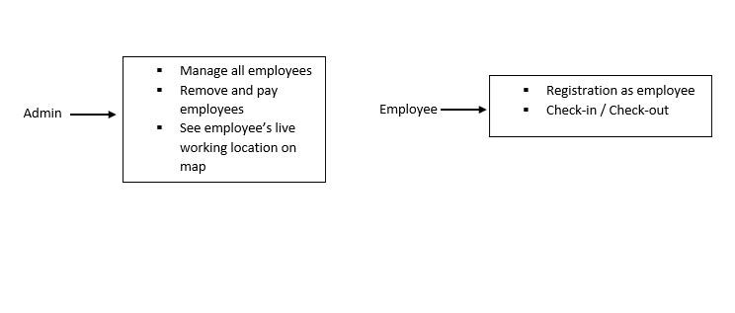

Figure 3.1: Requirement Collection and Analysis.

**3.2 Use Case Modeling and Description**

A use-case model is a model of how different types of users interact with the system to solve a problem.

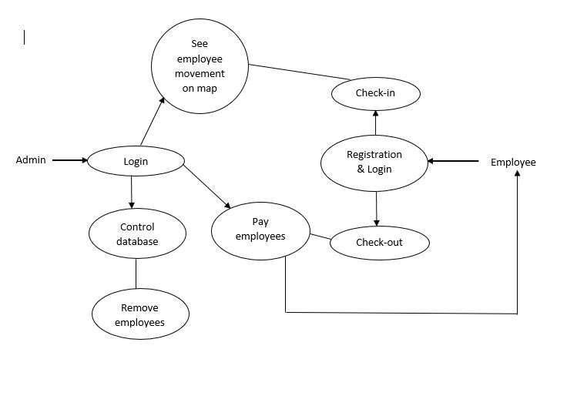

Figure 3.2: Use Case Modeling and Description

**3.3 Logical Data Model**

API will be called and the response will be sent to the application which is shown in the Logical Data Model figure and it will be the current time responsible. Data will transfer from database to android application.

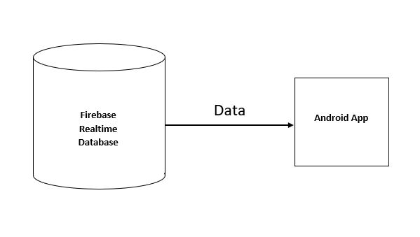

Figure 3.3: Logical Data Model

**3.4 Design Requirements**

Design requirements are very important for mobile applications. It attracts the user to use it. So, to complete the design, we must have mobile application design skills. For this, we have to know the various types of computer programming languages and design tools like AdobeXd. Market analysis can be a good trick for the design. We have to give proper attention to designing the database so that it works appropriately and easily.

**Chapter 4**

**Design Specification**

**4.1 Front-End Design**

Front-End is the place where the user interacts. So, considering this factor, we have created a user-friendly and smooth design. Every user can easily use this application.

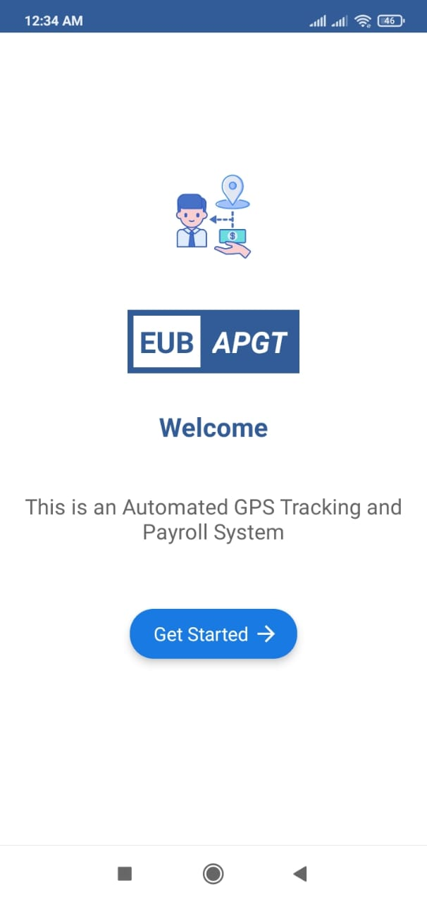

Figure 4.1: Front-End Design.

**4.2** **Interaction Design and UX**

We have tried to make our project UX design as simple as possible. Because we have researched on the internet and visited the various site, used various android applications. Then we made the UX design of our application.

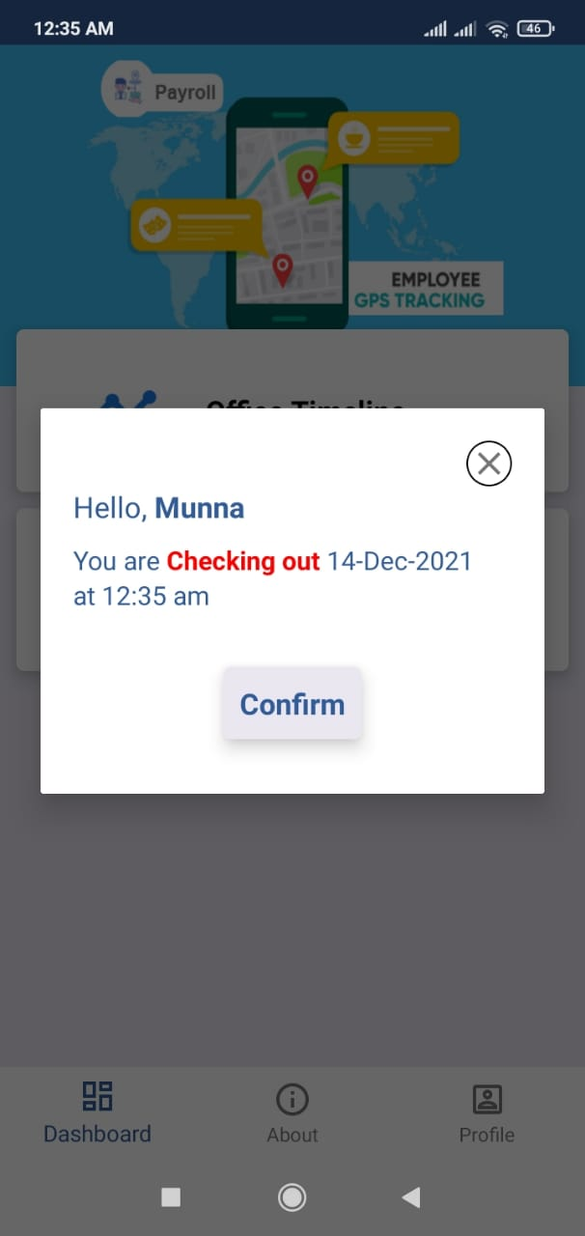

Figure 4.2: Interaction Design and UX

**4.3 Back-End Design**

Basically, in software development, back-end means rendering server-side. Usually, the backend programming consists of three parts: application, server, and database. For the backend database, we have used Firebase Real-time Database and other implemented back-end technologies that are Native Android with Java.

**4.4 Implementation Requirements**

It was our environment & geography-related work. So, we had to learn a lot of new technologies and spent a huge time to fulfill all the requirements.

**Chapter 5**

**Implementation and Testing**

**5.1 Implementation of Database**

Implementation of the database was fundamental for this application. In this project, we have used Firebase for user authentication and Firebase Real-time Database for data storage.

**5.2 Implementation of Front-end Design**

Front-end design is very essential because of its visualization to the users. Developing a design for an application, we have to consider the user-friendly and smooth front end. It is very difficult to make the perfect design that attracts all.

**Welcome Screen**



Figure 5.1: Welcome Screen

**Employee Dashboard**

Employee dashboard contains check-in/check-out and office timeline options.

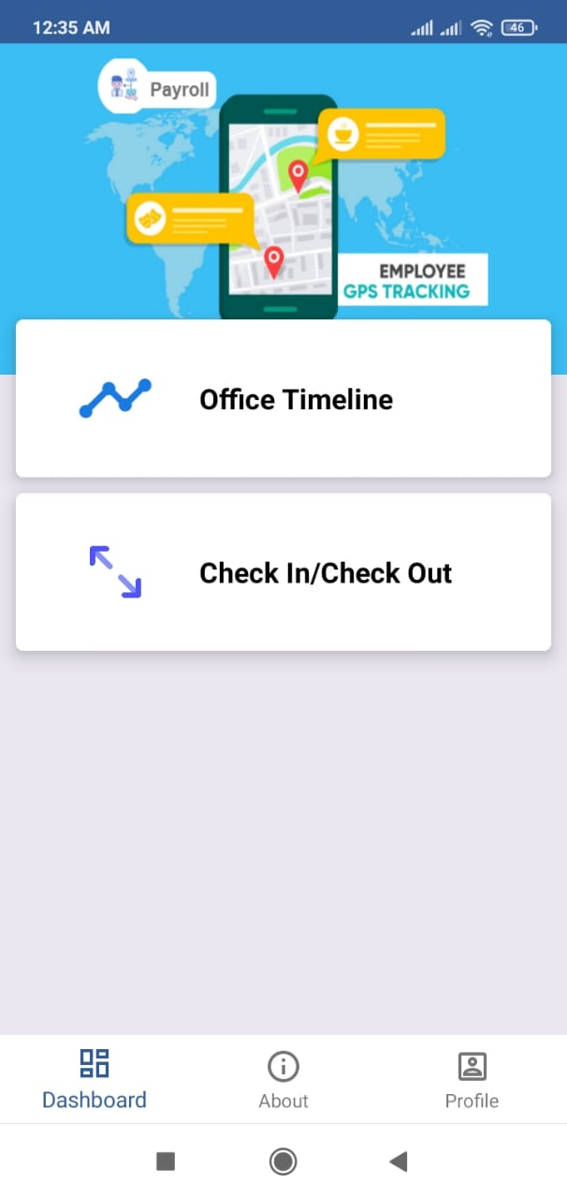

Figure 5.2: Employee Dashboard

**Office Timeline**

Users can see work hours, office environment/type, total employees, weekends, and other information about the company.

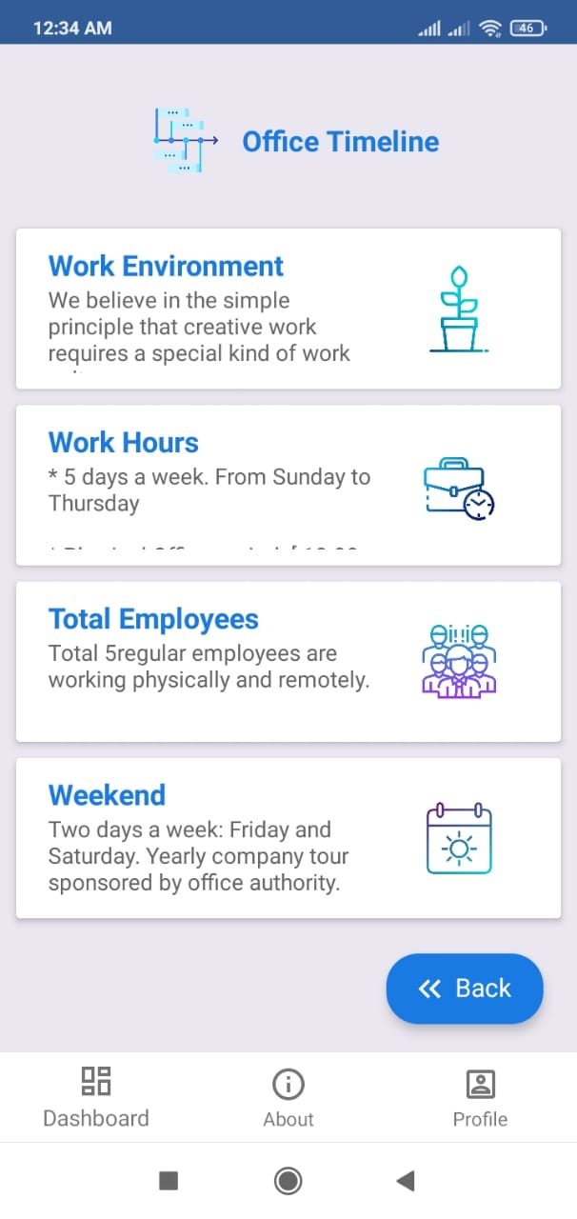

Figure 5.3: Office Timeline.

**Check-In**

Employees can check-in and the system will count the employee’s work hours from his/her check-in time.

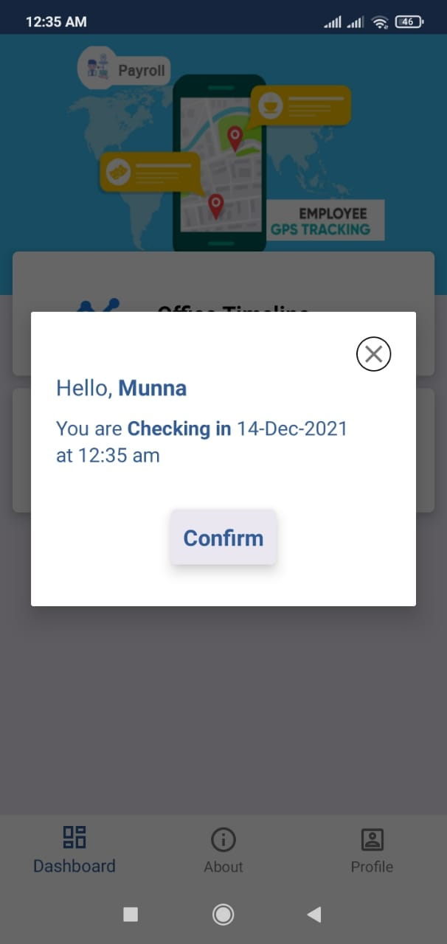

Figure 5.4: Check-in.

**Check-Out**

Employees can check out any time after checking in and the system will count the employee’s daily salary according to his/her total work hour.



Figure 5.5: Check-out.

**Admin Dashboard**

Admin dashboard contains office timeline, total employees, and on-field working employees and sees their live location on the map, payment history.

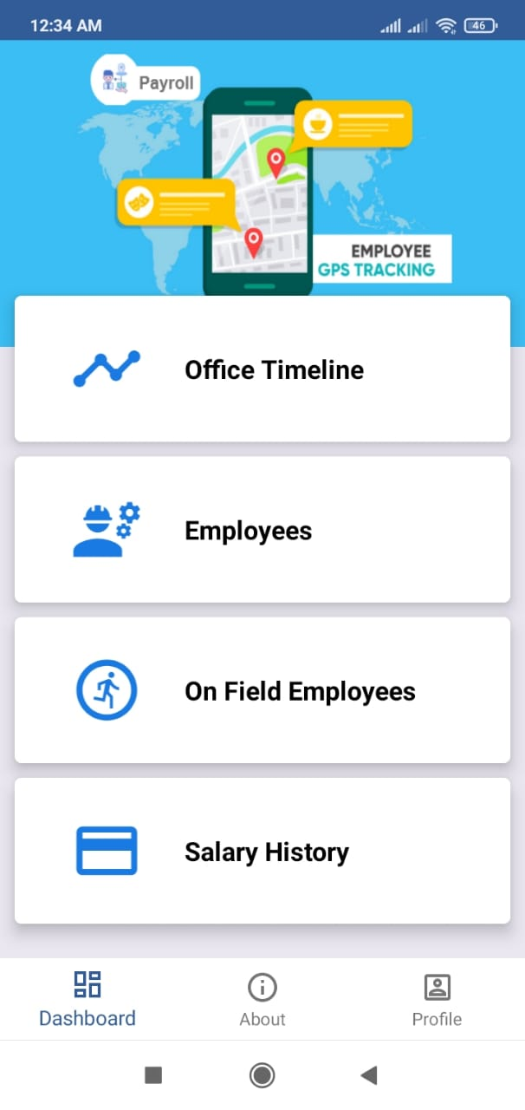

Figure 5.6: Admin Dashboard.

**Total Employee List**

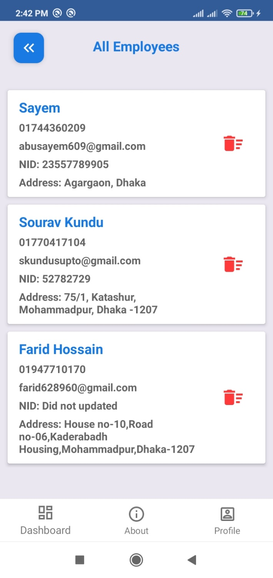

Figure 5.7: Total Employee.

**On-Field Employees**

Employee list those are working now.

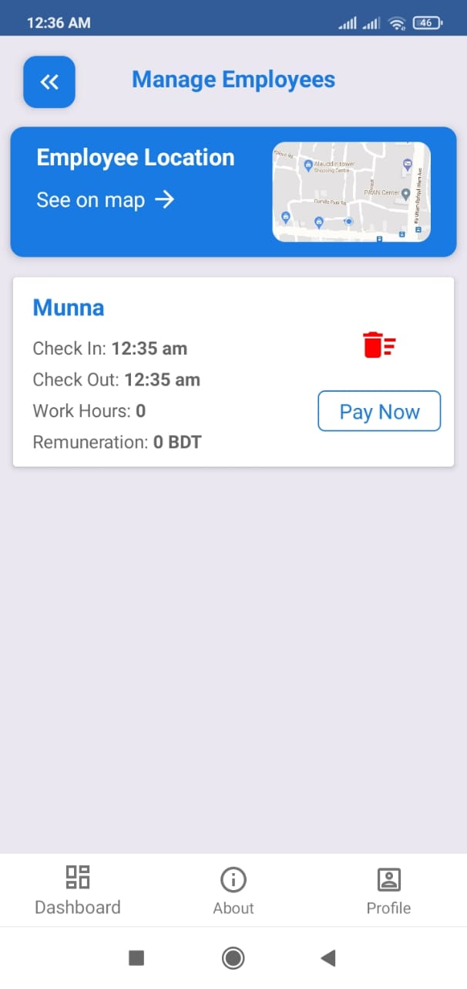

Figure 5.8: On-field employees

**Salary History**

List of payment history in which employees are being paid.

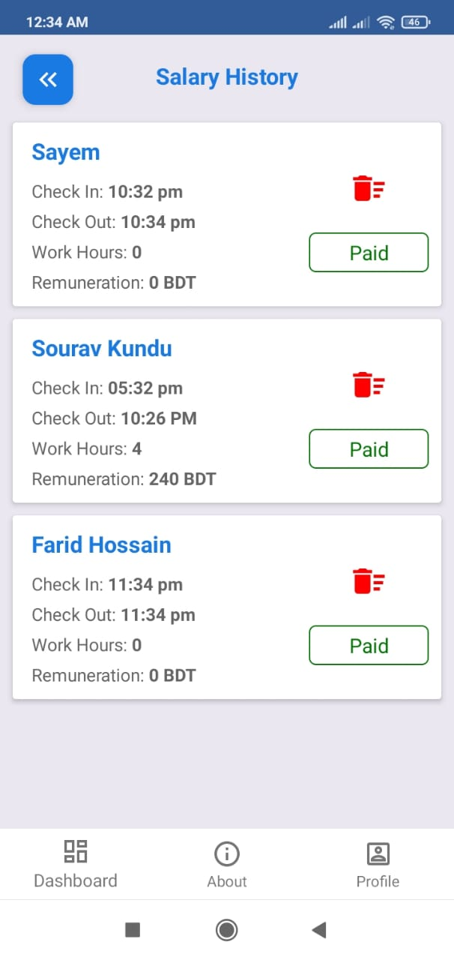

Figure 5.9: Salary history.

.

**Employee Location**

Employee’s live movement on the map.

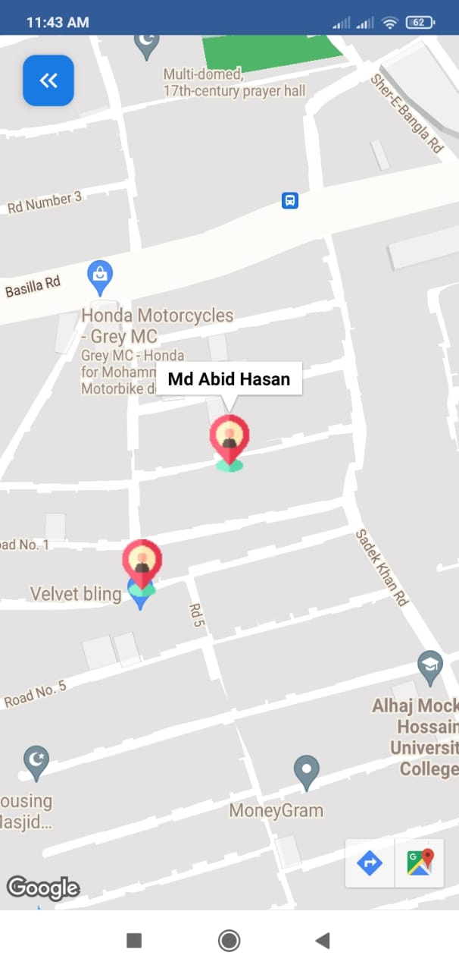

Figure 5.10: Employee location

**Profile**

User information in the profile section.

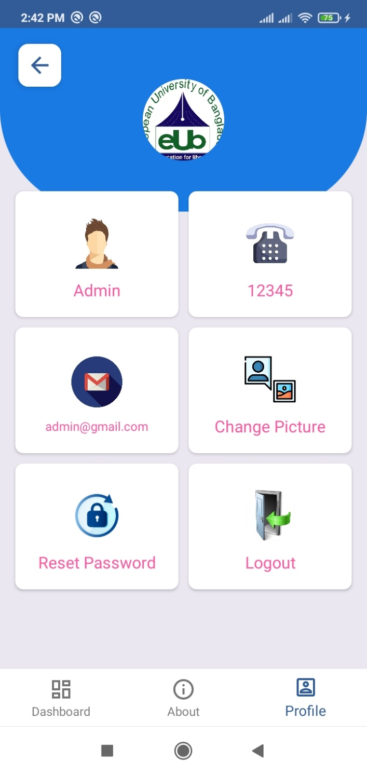

Figure 5.11: Profile

**About**

App title and version name, developers and supervisor information in about section.

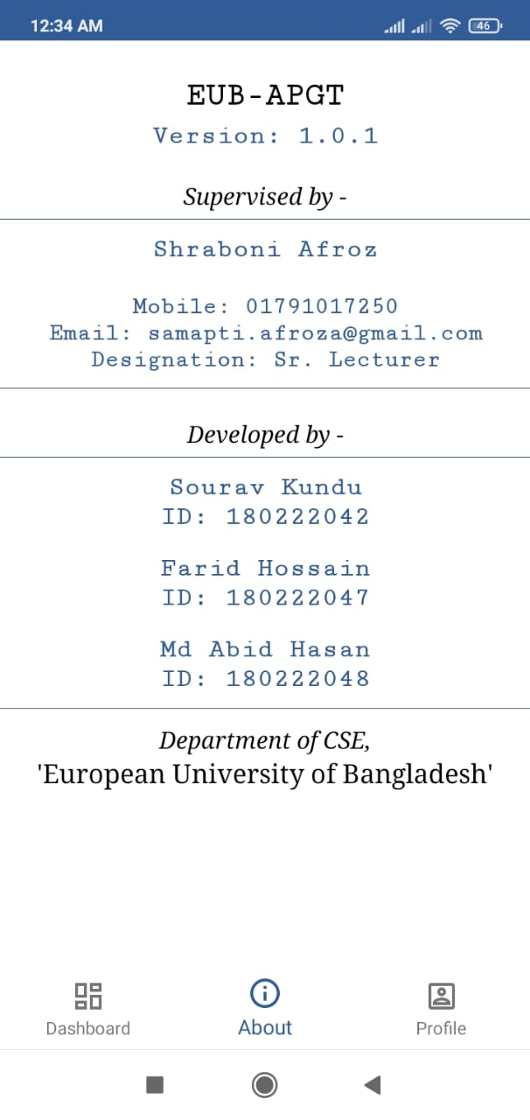

Figure 5.12: About

**Chapter 6**

**Impact on Society, Environment, and Sustainability**

**6.1** **Impact on Society**

This application will be beneficial for any kind of organization and employees of them.

**6.2 Limitation**

No application is perfect. Every system has some limitations. The limitations of our project are written below:

* Well maintenance of back-end by developing web applications.

**6.3 Obstacles & Achievements**

During the development of the application, we have faced a lot of obstacles and successfully overcame most of them. Some of the obstacles were:

* We had to study office and employee management systems.
* Google map API integration was a bit difficult for locating live workers/employees.

Finally, after developing the project, we have successfully achieved:

* Automated payroll and GPS tracking app which provides office admin to get the current worker’s location/movement on the map and pay them with this automated system.

**Chapter 7**

**Conclusion and Future Scope**

**7.1 Discussion and Conclusion**

We are introducing automated payroll using GPS location tracking which uses to view an employee by using the employee’s geographical location and locate the longitude and latitude positions and we can view the path the way he traveled throughout the day and calculate the employee salary, it eradicates the proxy attendances and fake salary calculations.

**7.2 Scope for Further Developments**

Due to the limitation of time, knowledge, and experience, we couldn’t develop some features of our project. In the future, we want to develop those features one by one. Those features are:

* Push Notification to let the admin know the live status of their workers.
* Publish the app on Play Store.

**References**:

[1] RIP Tutorial for implementing Google Map in android application, available at <<<https://riptutorial.com/android/topic/4111/android-places-api>>>, last accessed on 05-12-2021 at 12:00 P.M.

[2] Youtube for Android Tutorial at << <https://www.youtube.com/> >>, last accessed on 12-12-2021 at 10:00 A.M.

[3] Heartbeat. Comet for customizing Google Map available at <<<https://heartbeat.comet.ml/customize-google-maps-in-android-66618fade492?gi=326e53229902>>>, last accessed on 23-11-2021 at 01:00 P.M.

[4] Material Design for Android, available at << <https://material.io/develop/android> >>, last accessed on 9-10-2021 at 12:00 A.M.

[5] Build location aware app, available at <<<https://developer.android.com/training/location>>>,

last accessed on 12-09-2021 at 12:00 A.M.

[6] Live location request and longitude, lattitude permission, available at

<<<https://developer.android.com/training/location/permissions> >>, last accessed on 12-09-2021

at 12:00 A.M.